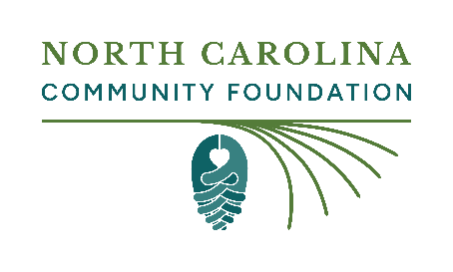

Announcing scholarship availability

Sending a news release can be a great way to publicize your scholarship with media outlets and other interested parties. Below are a few suggestions on how best to reach and work with your local news media.

Localize

Tailor the news release template provided on Page 2 to include information about your scholarship. Please use scholarship names, descriptions and affiliate foundation names from the NCCF scholarship listing. Do not add too much background information as many news outlets will not print the press release and be sure to proofread your news release before you send it!

Getting the word out

Media outlets: Send a news release to media outlets via email. Give some thought to the most logical recipients for this type of news. Check out the media outlet’s staff directory located on their website. If it’s not clear, you can call or email the media outlet and ask prior to sending, but it would typically be staffers responsible for covering community news or education.

Other community sources of information: Think about where people get their news and information in your community. Are there Facebook groups or email newsletters you could share the information with? What about organizations involved in awarding the scholarship or the recipient’s high school or school system? Do not limit your outreach to just traditional media.

Social media: If local media outlets run the news release be sure to share the news on your social media and encourage others from the scholarship committee to do the same. If media outlets don’t pick up the news release, don’t be discouraged! Use our social media template to share the news on your Facebook, LinkedIn, Twitter or Instagram. Be sure to tag the North Carolina Community Foundation.

<SCHOLARSHIP NAME> now open for applications for <COUNTY/SCHOOL> students

<DATE, YEAR> – <SCHOLARSHIP NAME> is accepting applications from students now through <APPLICATION DEADLINE>. The scholarship is administered by the North Carolina Community Foundation.

To be eligible for <SCHOLARSHIP NAME>, students must <IF YOUR SCHOLARSHIP HAS ANY SPECIFIC ELIGIBILITY CRITERIA SUCH AS ATTENDANCE AT A SPECIFIC HIGH SCHOOL OR RESIDENCY REQUIREMENTS NOTE THAT HERE>. To learn more about how to apply, visit nccommunityfoundation.org/Scholarships.

“QUOTE FROM SCHOLARSHIP ADMINISTRATOR ABOUT WHY STUDENTS SHOULD APPLY FOR THIS SCHOLARSHIP” said <SCHLOARSHIP ADMINISTRATOR NAME>, who leads the committee awarding the scholarship.

The scholarship was established to <IF RELEVANT, INCLUDE BRIEF DETAILS ABOUT THE REASON THE SCHOLARSHIP WAS FOUNDED, PERSON IT HONORS OR MEMORIALIZES>.

About the North Carolina Community Foundation

The North Carolina Community Foundation transforms the collective generosity of our donors into a permanent source of community support, with a focus on the state’s rural areas.

NCCF partners with donors and a network of affiliates to sustain over 1,300 endowments totaling nearly $570 million in assets. More than $338 million has been awarded as grants to charitable organizations and scholarships to students, creating stronger communities for generations to come.

To learn more about how we turn generosity into impact, visit nccommunityfoundation.org.

###

Contact: <NAME OF SCHOLARSHIP ADMINISTRATOR, EMAIL AND/OR PHONE NUMBER>

*Note to news media: This news release was sent by the scholarship administrator. For further information about the scholarship or NCCF, visit nccommunityfoundation.org.

